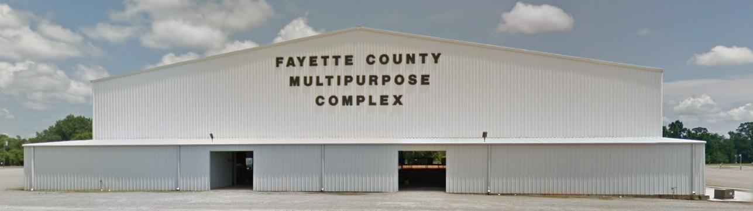
Upcoming Events
----------------------------------
Feb 1 Indoor MotoCross
Information: Josh Aaron 205-712-3307
-------------------------------------------------------
Feb 22 - 23 Indoor MotoCross
Information: Josh Aaron 205-712-3307
-------------------------------------------------------
March 28 Joe Maddox Auction
Information: Joe Maddox 207-270-3182
-------------------------------------------------------
April 17 – 18 Cattleman’s Rodeo
Information: Charley Dale Jones 205-932-3416
-------------------------------------------------------

