The Clan of Robertson (Part 1)

In 1843, a young man of 21 years boarded a ship from his home country of Scotland and sailed into the port of New Orleans, LA. After stepping upon U. S soil, John Crichton Robertson proceeded to Mobile and stayed for a while with the Thomas Henry family with whom he had become friendly aboard ship. From Mobile he traveled to Columbus, MS and hitched a ride with a mule train to Fayette Court House town. John C. Robertson was a tailor by trade and arrived in Fayette C.H. in 1844 with a pair of scissors and 75 cents in his pocket.

Fayette C.H. town, barely older than John C. Robertson himself, was fertile ground for starting a business. There were no stores as yet, what supplies families who lived in Fayette C.H needed but were unable to furnish for themselves came periodically by mule train or ox-carts. Few people owned custom, tailor-made suits or clothing.

Robertson immediately set about learning the language, getting to know the people and establishing his tailor business. He worked hard, scrimped and saved and at the end of his first year in Fayette C.H. he was independently established. If a gentleman ordered a tailor-made suit and was unable to pay for it, John C. would trade a suit of clothing for 40 acres of land. Although this swap may seem like an extremely high price in today’s market, land at that time was plentiful and sold for as little as 3 and ½ cents per acre.

In 1847, twenty-four year old John Crichton Robertson married fifteen-year old Mary Fletcher Alley. They became the parents of fourteen children, eight sons and six daughters. Three of the children died in infancy.

Mary Fletcher was also a hard worker, as well as spunky and independent in her thinking. She spent many a night alongside John C. sewing by the light of a log on the fire to complete an order. Knowing he would soon have a family to support, John C. thought of moving to New York where the tailoring business was thriving. Mary, however, refused to go with him. This decision set in motion the evolution of the Robertson legacy in Fayette.

John C. Robertson’s tailor shop became the town’s gathering place. Gentlemen stopped by to “sit a spell”, discuss politics and local issues and inquire about fashion and items unavailable in Fayette Court House town. In the latter part of the year of 1847, John C. opened the town’s first store across the road from the courthouse which was located on the hill above 5-points.

As the town grew and prospered so did Robertson’s store. In 1856 he built a 2-story masonry building to house his merchandise. John C. was a devout, fair and admired man who had by this time become one of the most respected leaders of his town and his church. People came from throughout the county and surrounding areas to do business with him.

Records show John C. Robertson was the president of the Fayette Division of the Sons of Temperance in 1851. The Sons of Temperance was a brotherhood of men who promoted the temperance movement (moderation in all things and an abstinence from alcoholic drinks) and the mutual support of the brotherhood. Membership was very restricted and required a $2.00 initiation fee and weekly dues of six cents. The brotherhood was required to pay $30.00 toward the cost of burial of a member and $15.00 toward the cost of burial for a member’s wife. They were required to visit any sick brother at least once a day.

Profits from the tailoring business skyrocketed during the early 1860’s and throughout the first years of the War Between the States, Robertson’s tailoring skills were much in demand. He and Mary sewed day and night supplying the uniforms for soldiers going to war.

John C. Robertson untiringly helped rear his 11 children, continued his tailoring business, ran the store, purchased land with his profits whenever it became available and even owned a newspaper, the Fayette Gazette.

After the courthouse burned in April of 1866, the county commissioners undertook building a new courthouse of brick. John C. furnished a house for the court until the new courthouse could be built. He sent supplies from his store for the hands that were working at the brickyard firing the brick. He also loaned the county money to pay for new supplies of blank books for the office of Probate Judge. The county commission ordered that the re-building of the courthouse be let to the lowest bidder and that the bids be sealed. John C. Robertson was awarded the contract - his bid was for the sum of four thousand dollars.

Thirty–two years after leaving his home in Alyth, Perthshire, Scotland, to seek his fortune in the new world, John C. Robertson returned to his native land to visit his family, leaving Mary to run the store. The year was 1876. Their youngest child, Thomas Henry Robertson was 5 years old.

John C. had sent money for his brother, Robert, to join him in Fayette Court House many years earlier. Robert opened a harness shop near Robertson’s store. While he was in Scotland John C. spent time with two other brothers and the children of yet another brother, not knowing he was seeing them for the last time.

Upon his return to his adopted country, he sailed into New York. In a letter to his niece and nephew in Scotland he wrote: “On my arrival at New York, I then went for Philadelphia. I spent five days at the great Centennial and I saw more people in one day than I ever expect to see in one day again. Then started to Niagara Falls and I do think that it is the grandest sight I have ever seen in my life. I then left the falls for home and I traveled through the most beautiful parts of America. But after all my travels and grand sights I can say with poet there is no place like home.”

John Crichton Robertson died one year after returning to his beloved Fayette Court House. He was 55 years old.

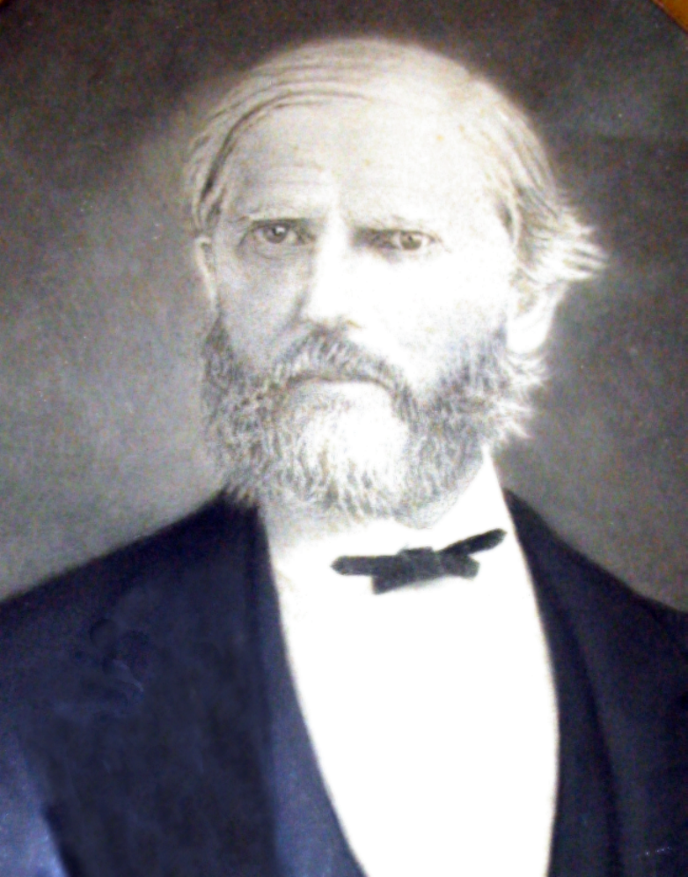

To be continued next week

